**Assignment # 03 & 04**



**SUBMITTED BY:**

**Awais Saddiqui**

**REG NO:**

**21PWCSE1993**

**SECTION:**

**“A”**

**SUMITTED TO:**

**Nasru Minallah Sir**

**UNIVERSITY OF ENGINEERING AND TECHNOLOGY PESHAWAR**

**COMPUTER SYSTEM ENGINEERING**

**Assignment # 03:**

**Source Code:**

#include <iostream>

using namespace std;

const int MAX = 20;

class IntegerSet {

private:

int st[MAX];

public:

IntegerSet() {

for (int i = 0; i < MAX; i++)

st[i] = 0;

}

void insertElement(int value) {

st[value] = 1;

}

void deleteValue(int value) {

st[value] = 0;

}

IntegerSet operator+(const IntegerSet& other) {

IntegerSet result;

for (int i = 0; i < MAX; i++)

if (st[i] == 1 || other.st[i] == 1)

result.insertElement(i);

return result;

}

IntegerSet operator*(const IntegerSet& other) {

IntegerSet result;

for (int i = 0; i < MAX; i++)

if (st[i] == 1 && other.st[i] == 1)

result.insertElement(i);

return result;

}

IntegerSet operator~() {

IntegerSet result;

for (int i = 0; i < MAX; i++)

if (st[i] == 0)

result.insertElement(i);

return result;

}

void display() {

cout <<"{ ";

for (int i = 0; i < MAX; i++)

if (st[i] == 1)

cout << i << ", ";

cout << "\b\b }\n";

}

};

main(){

IntegerSet s, t;

s.insertElement(2);

s.insertElement(5);

s.insertElement(7);

s.insertElement(3);

s.insertElement(18);

s.insertElement(16);

cout<< "Set s: ";s.display();

s.deleteValue(2);

s.deleteValue(8);

cout<< "After Deleting 2 and 8, s: ";s.display();

t.insertElement(3);

t.insertElement(5);

t.insertElement(7);

t.insertElement(13);

cout<< "\nSet t: ";t.display();

t.deleteValue(3);

cout<< "After Deleting 3, t: ";t.display();

IntegerSet u = s + t;

cout<< "\nUnion of s and t: ";u.display();

IntegerSet i = s * t;

cout<< "\nIntersection of s and t: ";i.display();

IntegerSet inv = ~u;

cout<< "\nComplement of Union of s and t: ";inv.display();

}

**Output# 03:**

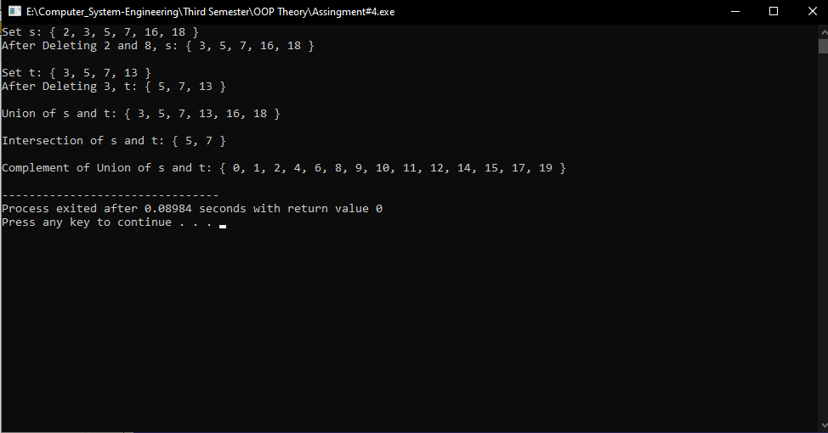

**Assignment # 04:**

**Source Code:**

#include <iostream>

#include <cstring>

#include <string>

using namespace std;

class employee{

private:

char *name, *department;

double salary, service;

public:

employee():name("Awais"),department("DCSE"),salary(10000),service(10){};

employee(char n[], char dep[], double sal, double ser):name(n),department(dep),salary(sal),service(ser){};

employee(const employee &test){

int nameLength = strlen(test.name);

int depLength = strlen(test.department);

name = new char[nameLength+1];

department = new char[depLength+1];

strcpy(name, test.name);

strcpy(department, test.department);

salary = test.salary;

service = test.service;}

void input(){

int nameLength = strlen(name);

name = new char [nameLength + 1];

cout<<"\nEnter Your Data !!!"<<endl;

cout<<"\nname:\t";

gets(name);

int depLength = strlen(department);

department = new char [depLength + 1];

cout<<"Department:\t";

gets(department);

cout<<"Salary : ";

cin>>salary;

cout<<"Service In Years : ";

cin>>service;

}

void show(){

cout<<"Employee Data"<<endl;

cout<<"Name : "<<name<<endl;

cout<<"Department : "<<department<<endl;

cout<<"Salary : "<<salary<<endl;

cout<<"Service : "<<service<<endl;

}

~employee(){

cout<<"\nObject Destroyed...";

delete[] name;

delete[] department; }

};

main(){

employee obj1;

obj1.show();

obj1.input();

obj1.show();

cout<<endl;

employee obj2=obj1;

obj2.show();}

**Output # 04:**

